Create a dockerfile, docker-compose file which when executed must display your basic details in the website.

Docker is an OS-level virtualization (or containerization) platform, which allows applications to share the host OS kernel instead of running a separate guest OS like in traditional virtualization. This design makes Docker containers lightweight, fast, and portable, while keeping them isolated from one another.

Before Docker:

Deploying applications across environments was often difficult, dependencies, configs, and OS variations caused “works here but not there” headaches.

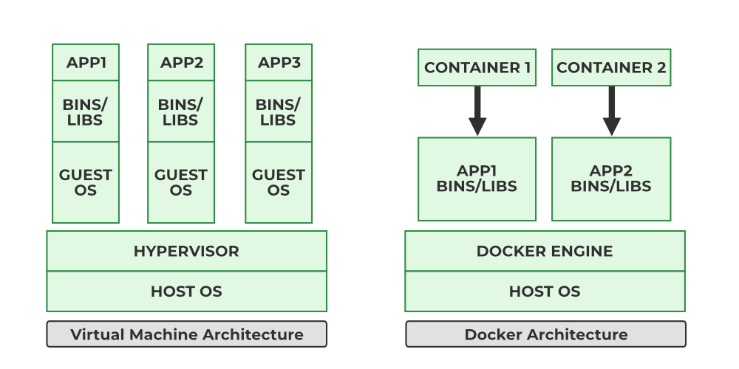

Docker’s Solution:

Standardizes the runtime environment by bundling everything (app + dependencies) into containers.

Portability: Runs anywhere in local machine, cloud, on-prem servers.

Consistency: Same behavior in development, testing, and production.

Lightweight: No full OS per app; containers share the host kernel.

Scalability: Ideal for microservices and orchestrators like Kubernetes and Docker Swarm.

Efficiency: Starts in seconds, uses fewer system resources.

Components of Docker

The following are the some of the key components of Docker:

Docker Engine: Docker Engine has a core part docker daemon , that handles the creation and management of containers.

Docker Image: Docker Image is a read-only template that is used for creating containers, containing the application code and dependencies.

Docker Hub: It is a cloud based repository that is used for finding and sharing the container images.

Dockerfile: It is a file that describes the steps to create an image quickly.

Docker Registry : It is a storage distribution system for docker images, where you can store the images in both public and private modes.

Docker Engine

The Docker Engine is the core component that enables Docker to run containers on a system. It follows a client-server architecture and is responsible for building, running, and managing Docker containers.

The Docker Engine Daemon (dockerd) runs in the background, listening to API requests and managing objects like images, containers, networks, and volumes.

The Docker Client (docker CLI) communicates with the daemon using a REST API.

It provides the execution environment where Docker Images are instantiated into live containers.

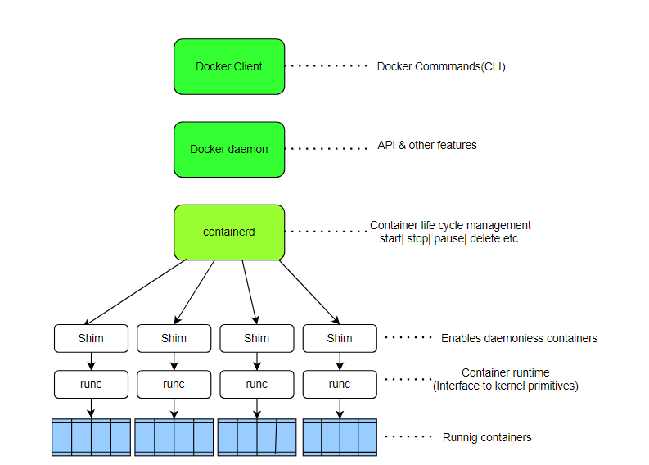

Without the Docker Engine, Docker images cannot be built or containers executed.

The Client sends Docker commands (docker build, docker run, etc.).

The Daemon receives these commands and performs container operations.

The REST API is the interface enabling this communication.

In short, the Docker Engine is the runtime that makes containerization possible by connecting the Docker client with the daemon to build and manage containers efficiently.

Dockerfile

The Dockerfile uses DSL (Domain Specific Language) and contains instructions for generating a Docker image. Dockerfile will define the processes to quickly produce an image. While creating your application, you should create a Dockerfile in order since the Docker daemon runs all of the instructions from top to bottom.

The Dockerfile is the source code of the image.

(The Docker daemon, often referred to simply as "Docker," is a background service that manages Docker containers on a system.)

It is a text document that contains necessary commands which on execution help assemble a Docker Image.

Docker image is created using a Dockerfile.

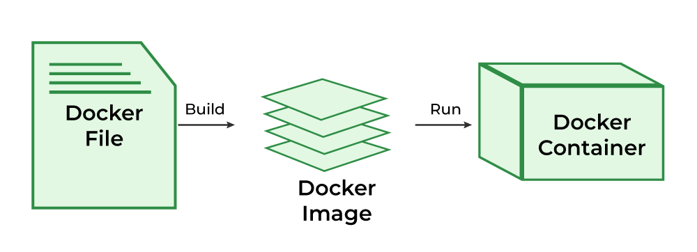

Docker Architecture and Working

Docker makes use of a client-server architecture. The Docker client talks with the docker daemon which helps in building, running, and distributing the docker containers. The Docker client runs with the daemon on the same system or we can connect the Docker client with the Docker daemon remotely. With the help of REST API over a UNIX socket or a network, the docker client and daemon interact with each other.

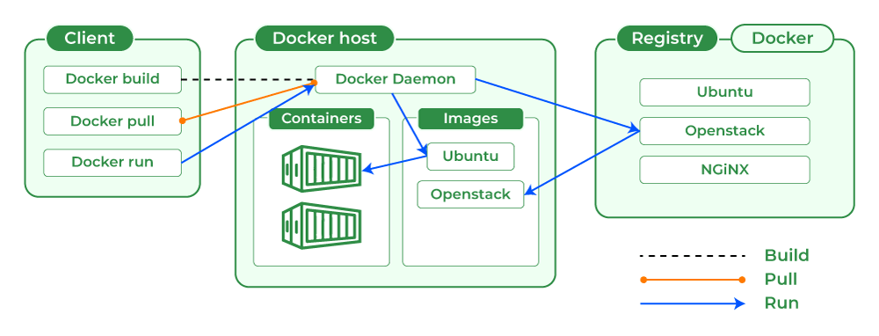

Docker CLI

Command-line interface to interact with Docker

Common commands: docker run, docker build, docker pull
Docker Rest API

HTTP API used by the CLI and other tools

Facilitates communication with the Docker daemon

Docker Daemon

Handles images, containers, networks, and volume

Core service that manages Docker objects

High-Level Runtime

Manages container lifecycle operations

Tasks include create, start, stop, and delete containers

Docker Image

A Docker Image is a file made up of multiple layers that contains the instructions to build and run a Docker container. t acts as an executable package that includes everything needed to run an application — code, runtime, libraries, environment variables, and configurations.

How it Works:

The image defines how a container should be created.

Specifies which software components will run and how they are configured.

Once an image is run, it becomes a Docker Container.

Relation to Containers:

Docker Image → Blueprint (static, read-only).

Docker Container → Running instance of that image (dynamic, executable)

Docker Container
A Docker Container is a lightweight, runnable instance of a Docker Image. It packages the application code together with all its dependencies and runs it in an isolated environment. Containers allow applications to run quickly and consistently across different environments — whether on a developer’s laptop, test servers, or production.

A container is created when a Docker Image is executed.

It runs as an isolated process on the host machine but shares the host’s operating system kernel.

Multiple containers can run on the same system without interfering with each other.

Relation to Images:

Docker Image = Blueprint (static, read-only).

Docker Container = Live instance of that blueprint (dynamic, executable)

Docker Hub

Docker Hub is a repository service and it is a cloud-based service where people push their Docker Container Images and also pull the Docker Container Images from the Docker Hub anytime or anywhere via the internet.

Generally it makes it easy to find and reuse images. It provides features such as you can push your images as private or public registry where you can store and share Docker images.

Mainly DevOps team uses the Docker Hub. It is an open-source tool and freely available for all operating systems. It is like storage where we store the images and pull the images when it is required. When a person wants to push/pull images from the Docker Hub they must have a basic knowledge of Docker. Let us discuss the requirements of the Docker tool.

Docker Commands

Through introducing the essential docker commands, docker became a powerful software in streamlining the container management process. It helps in ensuring a seamless development and deployment workflows. The following are the some of docker commands that are used commonly:

Docker Run: It used for launching the containers from images, with specifying the runtime options and commands.

Docker Pull: It fetches the container images from the container registry like

Docker Hub to the local machine.

Docker ps : It helps in displaying the running containers along with their important information like container ID, image used and status.

Docker Stop : It helps in halting the running containers gracefully shutting down the processes within them.

Docker Start: It helps in restarting the stopped containers, resuming their operations from the previous state.

Docker Login: It helps to login in to the docker registry enabling the access to private repositories.

Docker Engine

The software that hosts the containers is named Docker Engine. Docker Engine is a client-server based application. The docker engine has 3 main components:

Server: It is responsible for creating and managing Docker images, containers, networks, and volumes on the Docker. It is referred to as a daemon process.

REST API : It specifies how the applications can interact with the Server and instructs it what to do.

Client: The Client is a docker command-line interface (CLI), that allows us to interact with Docker using the docker commands.

Docker has two Editions:

Community Edition (CE): Free, open-source, used by individuals, dev teams, open-source contributors.

Enterprise Edition (EE): Paid, with security enhancements, certified plugins/images, and enterprise support.

Architecture of Docker

Docker follows a client-server architecture. The Docker client communicates with a background process, the Docker Daemon, which does the heavy lifting of building, running, and managing your containers. This communication happens over a REST API, typically via UNIX sockets on Linux (e.g., /var/run/docker.sock) or a network interface for remote management.

The Core Architectural Model

Docker Client: This is your command center. When you type commands like docker run or docker build, you're using the Docker Client.

Docker Host: This is the machine where the magic happens. It runs the Docker Daemon (dockerd) and provides the environment to execute and run containers.

Docker Registry: This is a remote repository for storing and distributing your Docker images.

This interaction forms a simple yet powerful loop: you use the Client to issue commands to the Daemon on the Host, which can pull images from a Registry to run as containers.

Detailed Breakdown of Core Components -

1. The Docker Daemon (dockerd):

The Docker Daemon is the persistent background process that acts as the brain of your Docker installation.

It runs on the Docker Host.

It listens for API requests from the Docker Client.

It manages all Docker objects: images, containers, networks, and volumes.

It can communicate with other daemons to manage Docker services in a multi-host environment (like a Docker Swarm cluster).

2. The Docker Client:

The Docker Client is the primary interface through which users interact with Docker. This is most commonly the Command Line Interface (CLI).

It translates user commands like docker ps into REST API requests.

These requests are sent to the Docker Daemon for processing.

A single client can communicate with multiple daemons.

Common Commands:

docker build: Builds an image from a Dockerfile.

docker pull: Pulls an image from a registry.

docker run: Creates and starts a container from an image.

3. The Docker Host

The Docker Host is the physical or virtual machine that provides the complete environment for executing and running containers. It comprises:

The Operating System (and its kernel).

The Docker Daemon.

Images that have been pulled or built.

Running Containers.

Networks and Storage components.

4. The Docker Registry

A Docker Registry is a stateless, scalable storage system for Docker images.
Public Registry: The default public registry is Docker Hub, which contains a vast collection of community and official images.
Private Registries: Organizations often use private registries (like Harbor, AWS ECR, or Google Artifact Registry) to store proprietary images for security and control.

Docker Objects

Whenever we are using a docker, we are creating and use images, containers, volumes, networks, and other objects. Now, we are going to discuss docker objects:-

1. Images

An image is a read-only, inert template that contains the instructions for creating a Docker container. Think of it as a blueprint or a class in object-oriented programming.

It's built from a Dockerfile, a simple text file defining the steps to assemble the image.

Images are built in layers, where each instruction in the Dockerfile corresponds to a layer. This layered architecture makes builds and distribution incredibly efficient.

2. Containers

A container is a runnable, live instance of an image. If an image is the blueprint, a container is the house built from that blueprint.
You can create, start, stop, move, or delete containers using the Docker API or CLI.

Each container is isolated from other containers and the host machine, having its own filesystem, networking, and process space.

You can run multiple containers from the same image.

3. Storage

Since a container's writable layer is ephemeral (data is lost when the container is deleted), Docker provides robust solutions for data persistence. Storage driver controls and manages the images and containers on our docker host.

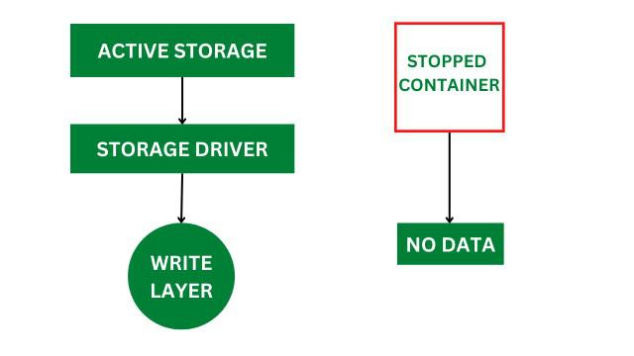

Types of Docker Storage

Docker provides multiple storage options to persist, share, and manage data across containers and hosts.

Volumes: The preferred mechanism. Volumes are managed by Docker and stored in a dedicated area on the host filesystem (e.g., /var/lib/docker/volumes/ on Linux). They are designed to survive the container lifecycle.

Bind Mounts: Allow you to map a file or directory from the host machine directly into a container. This is very useful for development, where you might want to share source code with a container.

tmpfs Mounts: In-memory storage that is temporary and never written to the host filesystem. Useful for sensitive data or high-performance temporary files.

Docker Networking

Docker networking provides complete isolation for docker containers. It means a user can link a docker container to many networks. It requires very less OS instances to run the workload.

Types of Docker Network

Bridge: It is the default network driver. We can use this when different containers communicate with the same docker host.

Host: When you don't need any isolation between the container and host then it is used.

Overlay: For communication with each other, it will enable the swarm services.

None: It disables all networking.

macvlan: Assigns a unique MAC address to a container, making it appear as a physical device on your network.

You run the command: docker run -d -p 80:80 nginx

Client: The Docker Client sends a REST API request to the Docker Daemon to create and run a container from the nginx image.

Daemon: The Daemon receives the request. It first checks if the nginx image exists locally on the Host.

Registry (Pull): If the image is not found locally, the Daemon contacts the configured Registry (Docker Hub by default) and pulls the nginx image.

Runtime (containerd): The Daemon hands the image and run-configuration over to containerd.

Runtime (runc): containerd uses runc to create a new container. runc interfaces with the Linux kernel to create
isolated namespaces and limit resources with cgroups.

Execution: The container is started. Docker maps port 80 of the host to port 80 of the nginx container, as requested by the -p 80:80 flag. The Nginx process runs as PID 1 inside the container's isolated PID namespace.

How to Build a Web Server Docker File

Requirements:
Installed docker software in your respective operating system.

Step 1: The first step is to build our Docker file for which you can use vim editor.

vim Dockerfile

FROM ubuntu
ENV DEBIAN_FRONTEND=noninteractive
RUN apt-get update
RUN apt-get install apache2 -y
RUN apt-get install apache2-utils -y
RUN apt-get clean
EXPOSE 80
CMD ["apache2ctl","-D","FOREGROUND"]

Description of the above commands

Ubuntu is our base image in which we are launching our server.

In the second line, is to set a non-interactive environment.

In the third line, the apt-get update command is used to update all the packages on Ubuntu.

In the fourth line, we are installing apache2 on our image.

In the fifth line, we are installing all the necessary utility Apache packages.

In the sixth line, the apt-get clean command cleans all the unnecessary files from the system.

In the seventh line, the EXPOSE command is used to expose the port 80 of Apache in the container.

The last command is used to run apache2 in the background.

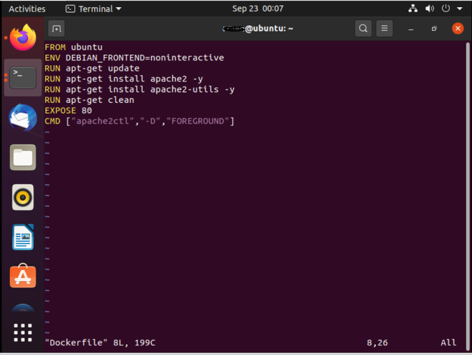

Step 2: Next step is to build the docker file by using the docker build command.

docker build -t="mywebserver"

Command:-t: this option is to tag the image, mywebserver is the tag to our image.

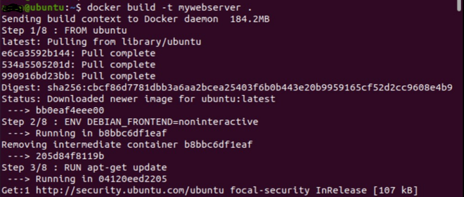

After the building of the image is finished, a message will print in the end that the has to build.

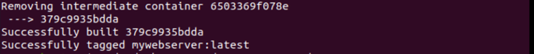

Step 3:
The web server file has built, the next step is to create a container from the image for that we use the docker run command.

docker run -d -p 80:80 tag_name

Commands:-d: This option is used to run the container in detached mode i.e the container
can run in the background.
-p: This option is used to map our port number with 5000 port numbers on our localhost.

Now run the docker images command to see the built image.

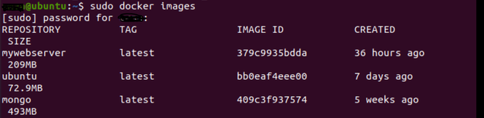

If you go to your web browser and write localhost_ip:80 your Apache server is up and running on that port.

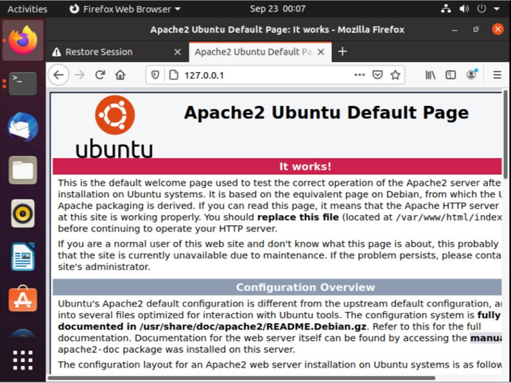

Docker Commands

Docker originally used straightforward, individual commands for each task. Over time, as more features were added, this approach became harder to manage. To make the interface clearer and more structured, Docker introduced an object-based command system, grouping commands by the type of resource they control.

Old Command | New (Recommended) Command | Purpose
docker ps | docker container ls | List containers
docker run | docker container run | Run a command in a new container
docker rm | docker container rm | Remove one or more containers
docker images | docker image ls | List images
docker rmi | docker image rm | Remove one or more images

Docker Container Run command

This is the most fundamental command. It creates a new container from a specified image and then starts it. If the image is not found locally, Docker will automatically try to pull it first.

$ docker container run <image_name>
To give name of container
$ docker container run --name <container_name> <image_name>

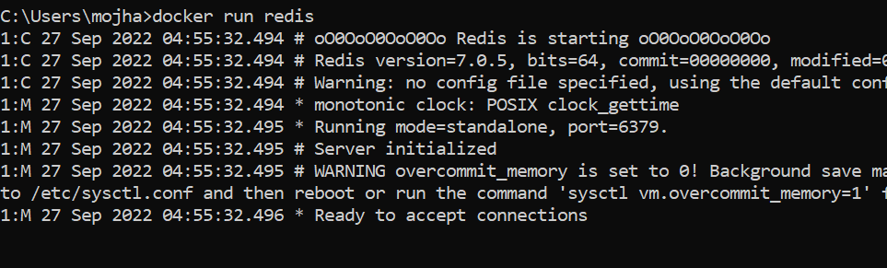

Docker Pull

This command allows you to pull any image which is present in the official registry of docker, Docker hub. By default, it pulls the latest image, but you can also mention the version of the image.

$ docker pull <image_name>

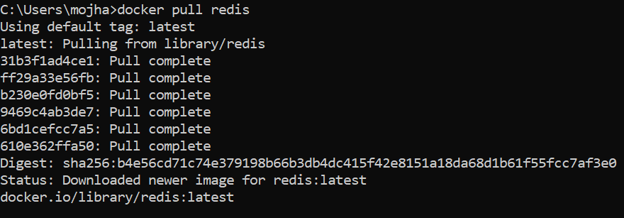

Docker PS

This command (by default) shows us a list of all the running containers. We can use various flags with it.

-a flag: shows us all the containers, stopped or running.

-l flag: shows us the latest container.

-q flag: shows only the Id of the containers.

$ docker ps [options..]

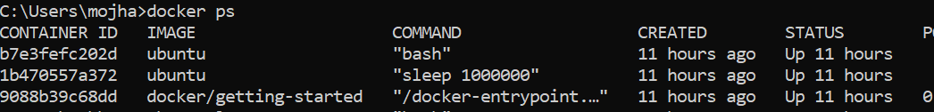

Docker Container Stop

This command allows you to stop a container if it has crashed or you want to switch to another one.

$ docker container stop <container_ID>

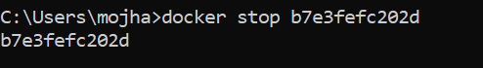

Docker Container Start
Suppose you want to start the stopped container again, you can do it with the help of this command.

$ docker container start <container_ID>

Docker rm

Removes one or more stopped containers. You cannot remove a container that is still running; you must stop it first. You can use the docker stop <container_name or ID> command to stop the container.

Some important flags:

-f flag: remove the container forcefully.

-v flag: remove the volumes.

-l flag: remove the specific link mentioned.

$ docker rm {options} <container_name or ID>

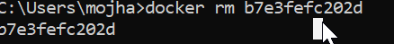

Docker RMI

To delete the image in docker. You can delete the images which are useless from the docker local storage so you can free up the space

docker rmi <image ID/ image name>

Docker Images

Lists all the pulled images which are present in our system.

$ docker images

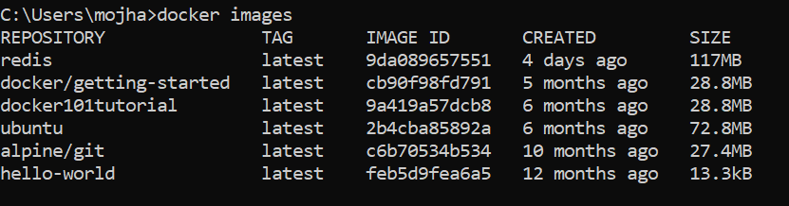

Docker exec

This command allows us to run new commands in a running container. This command only works until the container is running, after the container restarts, this command does not restart.

Some important flags:

-d flag: for running the commands in the background.

-i flag: it will keep STDIN open even when not attached.

-e flag: sets the environment variables

$ docker exec {options}

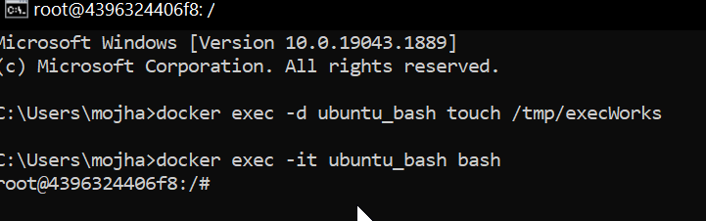

Docker Ports (Port Mapping)

In order to access the docker container from the outside world, we have to map the port on our host( Our laptop for example), to the port on the container. This is where port mapping comes into play.

$ docker run -d -p <port_on_host> <port_on_container> Container_name

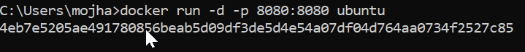

Docker Login

The Docker login command will help you to authenticate with the Docker hub by which you can push and pull your images.

docker login

Docker Push

Once you build your own customized image by using Dockerfile you need to store the image in the remote registry which is DockerHub for that you need to push your image by using the following command

docker push <Image name/Image ID>

Docker Build

The docker build command is used to build the docker images with the help of Dockerfile.

docker build -t image_name:tag .

In the place of image_name use the name of the image you build with and give the tag number and . "dot" represents the current directory.

Prune Command

This is a powerful command that removes all unused Docker objects in one go. By default, it removes:

All stopped containers.

All Build Cache.

All unused networks.

All dangling images (images that are not tagged and not used by any container).

Docker Compose

Docker compose is an orchestration tool for defining & running multi container docker applications imagine you have a complex application with separate components a web server, a backend api , a database and catching layer.
Each component run its own isolated container

Overcoming the Complexity of Multi-Container Setups

Docker is excellent at creating and running individual containers, managing the lifecycle and communication between them manually presents significant challenges:

Complex Configuration: Running each container requires long and complex docker run commands with flags for networking, ports, volumes, and environment variables. This becomes difficult to manage and reproduce consistently.

Manual Networking: To make containers talk to each other, you would have to manually create Docker networks, find the internal IP address of each container, and hardcode these fragile, temporary IPs into your application's code.

Lack of Reproducibility: A manual setup is prone to human error and makes it incredibly difficult to ensure that the application runs the same way on a developer's machine, a testing server, and in production. This is the classic "it works on my machine" problem.

Docker Compose directly addresses these issues by providing a declarative, automated, and reproducible way to manage your entire application stack. You declare the desired state of your application in the YAML file, and Docker Compose handles the rest.

Example docker-compose.yml

version: '3.8'
services:
web:
image: nginx:latest
ports:
- "80:80"
networks:
- frontend
volumes:
- shared-volume:/usr/share/nginx/html
depends_on:
- app
app:
image: node:14
working_dir: /app
command: node server.js # Specify a command
networks:
- frontend
volumes:
- shared-volume:/app/data
networks:
frontend:
driver: bridge
volumes:
shared-volume: # Remove incorrect syntax

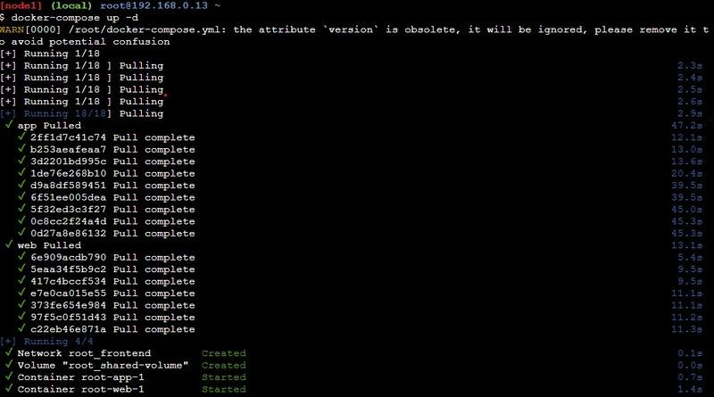

Docker Compose Services

In Docker Compose, every component of your application operates as a separate service, with each service running a single container tailored to a specific role—such as a database, web server, or cache.

These services are defined within the `services` section of the `docker-compose.yml` file. This section lets you configure each service individually, specifying details like the Docker image to pull, environment variables, network connections, and storage options.

Through this setup, you can control how each part of your application interacts, ensuring smooth communication and resource management across the services.

Key Service Configuration Options

Image: Image option defines which Docker image we are going to use by the service from the Docker Hub or any other registry.

Build: Instead of pulling an image, you can build one locally by specifying a directory containing a Dockerfile. The build is ideal for including custom code in your application.

Ports: This setting maps a container's internal ports to those on the host machine, enabling access to services from outside the container.

Volumes: Volumes attach persistent storage to a service ensuring that the data remains accessible even when a container restart.

Environment: Environment variables allow you to pass configurations or sensitive information, like database credentials or API keys, to the service.

Depends_on: Depends_on controls the startup order of services, ensuring that certain containers are running before others begin.

Example of docker-compose.yml Configuration

version: '3.8'
services:
db:
image: postgres:13
environment:
- POSTGRES_USER=user
- POSTGRES_PASSWORD=pass
volumes:
- db_data:/var/lib/postgresql/data
web:
build: ./web
ports:
- "5000:5000"
volumes:
- web_data:/usr/src/app
environment:
- DATABASE_URL=postgres://user:pass@db:5432/mydb
depends_on:
- db
volumes:
db_data:
web_data:

Install Docker Compose

We can run Docker Compose on macOs, Widows, and 64-bit Linux.

For any significant activity, Docker Compose depends on Docker Engine. Depending on your arrangement, we must ensure that Docker Engine is installed either locally or remotely.

A desktop system such as Docker for Mac and Windows comes with Docker Compose preinstalled.

Install Docker first as instructed in Docker installation on the Linux system before beginning the installation of Docker Compose.

Step 1: Update the package Manager

The following scripts will install the most recent version of Docker Compose and update the package management.

sudo apt-get update

Step 2: Download the Software

Here we are using the Ubuntu flavor in the Linux Operating system. So the package manager is "apt-get" If you want to install it in Redhat Linux then the package manager will be "yum".

Step 3: Apply Permissions

Apply the Executable permissions to the software with the following commands:

sudo chmod +x /usr/local/bin/docker-compose

Step 4: Verify the Download Software

Verify the whether the docker compose is successfully installed or not with the following command:

docker-compose --version

Step 1: Create Project Directory

First, Create a separate directory for our complete project. Use the following command.

mkdir dockerComposeProject

Move inside the directory
cd dockerComposeProject

Step 2: Create API

we will create a custom image that will use Python to serve our Restful API defined below. Then the service will be further configured using aDockerfile.
Then create a subdirectory for the service we will name it product. and move into the same.

mkdir product
cd product

Create requirement.txt
Inside the product folder, create a file named requirements.txt and add the following dependencies:
flask
flask-restful

Step 3: Build Python api.py
The following is the python file that helps in making an API call:
Create a Dockerfile to define the container in which the above API will run.
from flask import Flask
from flask_restful import Resource, Api
# create a flask object
app = Flask(__name__)
api = Api(app)
# creating a class for Fruits that will hold
# the accessors
class Fruits(Resource):
def get(self):
# returns a dictionary with fruits
return {
'fruits': ['Mango', 'Pomegranate', 'Orange', 'Litchi']
}
# adds the resources at the root route
api.add_resource(Fruits, '/')
# if this file is being executed then run the service
if __name__ == '__main__':
# run the service
app.run(host='0.0.0.0', port=80, debug=True)

Step 4: Create Dockerfile For Python API

FROM python:3
WORKDIR /usr/src/app
COPY requirements.txt .
RUN pip install --no-cache-dir -r requirements.txt
COPY . .
CMD ["python", "api.py"]

FROM accepts an image name and a version that the docker will download from the docker hub. The current working directory's contents can be copied to the location where the server expects the code to be by using the copy command. Moreover, the CMD command takes a list of commands to start the service once the container has been started.
Step 5: Create PHP HTML Website

Move to the parent directory and create another subdirectory for the website.
cd ..
mkdir website
cd website
index.php
<!DOCTYPE html>
<html lang="en">
<head>
<title>Fruit Service</title>
</head>
<body>
<h1>Welcome to India's Fruit Shop</h1>
<ul>
<?php
$json = file_get_contents('http://fruit-service');
$obj = json_decode($json);
$fruits = $obj->fruits;
foreach ($fruits as $fruit){
echo "<li>$fruit</li>";
}
?>
</ul>
</body>
</html>
Now create a compose file where we will define and configure the two services, API and the website.
Move out of the website subdirectory using the following code.
cd ..
And then create the file name as . docker-compose.yaml
Step 6: Create Docker-compose.yaml file
The following is the sample docker compose file code:
version: "3"
services:
fruit-service:
build: ./product
volumes:
- ./product:/usr/src/app
ports:
- 5001:80
website:
image: php:apache
volumes:
- ./website:/var/www/html
ports:
- 5000:80
depends_on:
- fruit-service

Docker-compose.yaml File
The first line is optional where we specify the version of the docker-compose tool. Next services define a list of services that our application is going to use. The first service is fruit service which is our API and the second one is our website. The fruit service has a property build that contains the dockerfile that is to be built and created as an image. Volumes define storage mapping between the host and the container so that we can make live changes. Finally, port property exposes the containers port 80 through the host's 5001.
The website service does not use a custom image but we download the PHP image from the Docker hub and then map the websites folder that contains our index.php to /var/www/html (PHP expects the code to be at this location). Ports expose the container port. Finally, the depends_on specifies all the services on which the current service depends.
The folder structure after creating all the required files and directory will be as follows:

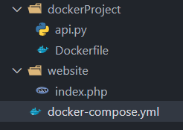

Run the application stack with Docker Compose
Now that we have our docker-compose.yml file, we can run it.
To start the application, enter the following command.
docker-compose up -d
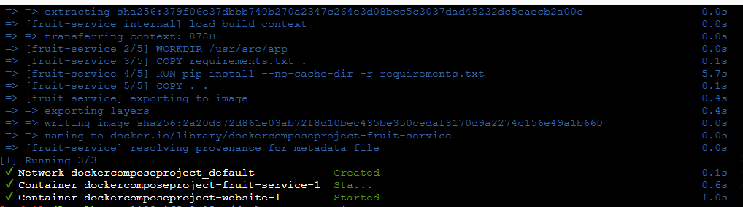

Open your browser and enter localhost:5000.
Output
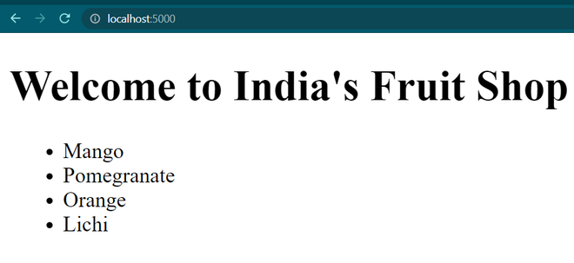

To stop the application, either press CTRL + C or
docker-compose stop

